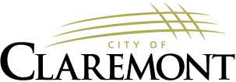
The Claremont City Council will hold a special meeting on Wednesday, October 2, 2024, at 6:00 p.m. in the Council Chambers of City Hall.

AGENDA

6:00 PM 1. PLEDGE OF ALLEGIANCE

6:02 PM 2. ROLL CALL

6:04 PM 3. NON-PUBLIC RSA 91-A:3, II (a)

8:00 PM 14. ADJOURNMENT

PLEASE NOTE: Claremont City Council’s next scheduled meeting will be on Wednesday, October 9, 2024, at 6:30 p.m. in the Council Chambers of City Hall.

